# Cover Page

**AGROPET VETCONNECT:**

**A Web-Based Platform for Veterinary Services in Nigeria**

**BY**

**CHUKWUNONSO ANIKPE LAWRENCE**

**BU/23A/IT/8001**

**DEPARTMENT OF COMPUTER SCIENCE**

**BAZE UNIVERSITY**

**ABUJA**

# SEPTEMBER, 2025

# Title Page

**AGROPET VETCONNECT:**

**A Web-Based Platform for Veterinary Services in Nigeria**

**Project Submitted in Partial Fulfilment of the Requirement for the Degree of**

**B. Sc.**

**In**

**Computer Science**

**By**

**CHUKWUNONSO ANIKPE LAWRENCE**

**BU/23A/IT/8001**

**To**

**The Department of Computer Science**

**Baze University, Abuja**

**September, 2025**

# DECLARATION

I hereby declare that this project entitled “AGROPET VETCONNECT: A Web-Based Platform for Veterinary Services in Nigeria” was carried by me under the supervision of Dr. Usman Bello Abubakar. The work has not been presented in any previous work for the award of a BSc degree to the best of my knowledge. The work is entirely mine and I accept the sole responsibility for any error that might be found in the work, while the reference to publish material have been duly acknowledged.

__________________________ _____________________

**CHUKWUNONSO ANIKPE LAWRENCE Date**

**BU/23A/IT/8001**

**APPROVED BY**

**_____________________**

**Head of Department,**

**Department of Computer Science**

# CERTIFICATION

This is to certify that this project entitled “AGROPET VETCONNECT: A Web-Based Platform for Veterinary Services in Nigeria”, being submitted by Chukwunonso Anikpe Lawrence in partial fulfilment of the requirement for the award of degree for B.Sc. in Computer Science to the Department of Computer Science, Baze University Abuja, Nigeria is a record of the candidate’s own work carried out by the candidate under my supervision. The matter embodied in this project is original and has not been submitted for the award of any other degree.

__________________________ _____________________

Date Dr Usman Bello Abubakar

# 

# 

# 

# APPROVAL

This is to certify that this project entitled, Design And Implementation of a Collaborative Academic Platform for Computer Science Students with Inter-University Leader Board Competitions by Chukwunonso Anikpe Lawrence with BU/23A/IT/8001 has been approved by the Department of Computer Science, Faculty of Computing and Applied Science, Baze University, Abuja, Nigeria.

**By**

----------------------- -----------------------

Full Name Date/Sign

Supervisor

----------------------- -----------------------

Dr. C. V. Uppin Date/Sign

Head, Department of Computer Sciences

----------------------- -----------------------

Prof. Peter Ogedebe Date/Sign

Dean, Faculty of Computing and Applied Science

----------------------- -----------------------

External Examiner Date/Sign

# 

# DEDICATION

I dedicate this work to God Almighty, whose grace and mercy made this accomplishment possible. To my family, whose endless love, support, and encouragement have kept me grounded and focused throughout my academic journey. And to all individuals passionate about improving lives through technology this project is a reflection of that vision.

# 

# ACKNOWLEDGMENT

I am deeply grateful to God Almighty for the wisdom, perseverance, and strength to complete this project. My profound appreciation goes to my supervisor, Dr. Usman Bello Abubakar, for his patience, guidance, and valuable insights. Special thanks to my parents and family for their unwavering support, motivation, and love. I also extend gratitude to my lecturers and colleagues in the Department of Computer Science, Baze University, whose teachings and encouragement inspired me. Finally, to everyone who played a role — directly or indirectly — in the success of this project, I say thank you.

# 

# 

# 

# 

# 

# ABSTRACT

# 

# 

**Table of Contents**

Cover Page 1

SEPTEMBER, 2025 1

Title Page 2

DECLARATION 3

CERTIFICATION 4

APPROVAL 5

DEDICATION 6

ACKNOWLEDGMENT 7

ABSTRACT 8

List of Tables 11

CHAPTER 1: INTRODUCTION 1

1.1 Background of the Study 1

1.2 Statement of the Problem 1

1.3 Aim and Objectives 1

1.4 Scope of the Project 2

1.5 Limitations of the Project 2

1.6 Significance of the Project 2

1.7 Risk Assessment 3

1.8 SWOT Analysis 3

1.9 Organization of the Project 4

Chapter Two 5

LITERATURE REVIEW 5

2.0 Introduction 5

2.1 Conceptual Review 5

2.1.1 Concept of Veterinary Service Delivery 5

2.1.2 Concept of Digital Platforms in Animal Healthcare 7

2.1.3 Concept of Veterinary Telemedicine 9

2.1.4 Concept of Centralised Veterinary Information Systems 10

2.1.5 Concept of Appointment Scheduling and Preventive Animal Healthcare 11

2.2 Thematic and Theoretical Review 11

2.2.1 Technology Acceptance Model and Digital Veterinary Platforms 11

2.2.2 Diffusion of Innovation Theory and Adoption of Veterinary Technologies 12

2.2.3 Information Systems Success Model and Platform Effectiveness 13

2.2.4 One Health Framework and Digital Veterinary Systems 14

2.3 Review of Related Empirical Literature 14

2.4 Identified Research and System Gap 17

References 19

# 

# List of Tables

# CHAPTER 1: INTRODUCTION

## 1.1 Background of the Study

In Nigeria, agriculture and animal husbandry are vital for sustaining rural livelihoods and contributing to the national economy. However, farmers and pet owners often struggle to access timely veterinary care, especially in remote areas where veterinary clinics are scarce (Babalobi, 2007). The rise of digital technology provides an opportunity to bridge this gap by connecting animal owners with veterinary professionals: digital platforms and mobile apps can enable remote consultation, appointment scheduling, and knowledge-sharing that reduce travel burdens and improve early disease detection (Lwoga, 2017; Teller, 2020). Studies of veterinary telemedicine and mobile veterinary applications show that telehealth tools increase access to care and can improve animal welfare when used alongside appropriate clinical oversight (Abu-Seida, 2024; Lundahl et al., 2022). In the Nigerian context, however, adoption is constrained by infrastructure gaps, limited digital literacy among rural users, and the need for verified veterinary content and localised services (Babalobi, 2007; PositiveNaija, 2022). Given these realities, the AgroPet VetConnect project aims to create an accessible web-based platform that connects Nigerian farmers and pet owners with certified veterinarians, provides a knowledge base of region-appropriate information, and supports appointment booking and reminders to improve livestock and pet health outcomes.

## 1.2 Statement of the Problem

Many small-scale farmers and pet owners in Nigeria face challenges in obtaining expert veterinary assistance when needed. Veterinary services are often concentrated in urban centers, requiring rural farmers to travel long distances for care. This lack of accessible animal healthcare can result in untreated diseases, loss of livestock, and poor animal welfare. Additionally, there is currently no unified system that allows animal owners from different regions to easily consult veterinarians or share knowledge. The absence of a centralized platform for veterinary support leads to inefficiencies, information gaps, and increased health risks in animal agriculture.

## 1.3 Aim and Objectives

The aim of this study is to design and implement AgroPet VetConnect, a web-based platform that connects Nigerian animal owners with veterinary professionals to improve animal healthcare and livestock management.

1. Objectives:  
   To develop an intuitive web and mobile interface where farmers and pet owners can register, log in, and post animal health queries.
2. To implement a database of certified veterinarians, allowing users to browse and select specialists based on animal type and location.
3. To incorporate features for scheduling appointments and sending reminders for livestock check-ups and pet treatments.

## 1.4 Scope of the Project

The scope of this project includes the development of an online platform accessible via web browsers and mobile devices throughout Nigeria. The system will focus on livestock (such as poultry, cattle, and goats) and common pets (such as dogs and cats). Core functionalities will include user registration, a veterinarian directory, appointment booking. This project will deliver a functional Minimum Viable Product (MVP) that addresses basic needs of veterinary connection and information sharing. Advanced features such as automated disease diagnosis, offline access, or integration with hardware (e.g., IoT tracking devices) are outside the scope of this initial phase.

## 1.5 Limitations of the Project

The limitations of this project are:  
- Internet connectivity is required to access the platform, which may exclude users in areas with poor network coverage.  
- Initial content may be limited, as the platform will launch with a small number of registered veterinarians and seed health information.  
- The system will not provide real-time remote diagnostics or telemedicine capabilities beyond messaging and scheduling.  
- Cultural and language diversity in Nigeria may limit usability if the platform initially supports only English and major regional languages.

## 1.6 Significance of the Project

This project is significant because it provides a centralized veterinary support network for Nigeria, a feature that can greatly improve animal health outcomes and agricultural productivity. By bringing veterinary expertise closer to farmers and pet owners, AgroPet VetConnect helps prevent the spread of diseases, reduce livestock losses, and enhance animal welfare. The platform encourages knowledge exchange and collaboration, building a community of users who learn from each other’s experiences. In the long term, better animal healthcare contributes to food security and economic growth in Nigeria’s agricultural sector. Adopting this system can modernize traditional veterinary care approaches and make expert advice more accessible.

## 1.7 Risk Assessment

Table 1.1: Risk Assessment

|  |  |  |
| --- | --- | --- |
| RISK DESCRIPTION | MITIGATION | IMPACT |
| Low user adoption in rural areas | Partner with agricultural agencies and NGOs to provide training and awareness campaigns | High |
| Inaccurate or inappropriate content on the platform | Implement content moderation, expert vet reviews, and a reporting system | Medium |
| Unstable internet connectivity | Optimize the platform for low bandwidth and consider SMS or offline notification options | High |
| Data privacy breaches and security vulnerabilities | Use strong encryption, secure authentication, and conduct regular security audits | High |

## 1.8 SWOT Analysis

Table 1.2: SWOT Analysis

|  |  |  |  |
| --- | --- | --- | --- |
| STRENGTHS | WEAKNESSES | OPPORTUNITIES | THREATS |
| Improves access to veterinary expertise nationwide Fosters a community of animal owners and vets Encourages preventive care through scheduling Centralizes animal health information | Depends on reliable internet connectivity Requires initial user base and data seeding Requires vet verification and content moderation Limited to online platform in first phase | Expansion to include more animal species Partnerships with government agencies and NGOs Potential integration with mobile payment systems Scale to other African markets with similar needs | Resistance to technology adoption by some users Competition from traditional veterinary clinics Misinformation if content is not well moderated Security breaches if platform data is compromised |

## 1.9 Organization of the Project

The project is organized into five chapters: Chapter 1: Introduction – Presents the background of the study, problem statement, objectives, scope, limitations, significance, risk assessment, SWOT analysis, and an overview of the project structure.

Chapter 2: Literature Review – Reviews existing research, frameworks, and systems related to veterinary services, animal health information systems, and agricultural technology platforms.  
Chapter 3: System Design and Architecture – Details the design of the AgroPet VetConnect system, including diagrams, data models, and technical architecture.

Chapter 4: Implementation and Testing – Describes the development process, technology stack, user interface, and reports on functional and usability testing of the platform.  
Chapter 5: Conclusion and Recommendations – Summarizes the project findings, evaluates how objectives were achieved, discusses limitations, and provides recommendations for future improvements.

# Chapter Two

# LITERATURE REVIEW

## ****2.0 Introduction****

This chapter presents a critical review of existing scholarly literature relevant to the design and implementation of a web based veterinary service platform in Nigeria. The review interrogates contemporary research on veterinary service delivery, digital health systems, agricultural information platforms, and technology enabled service coordination. Rather than summarising prior studies, the chapter evaluates how existing research conceptualises access to veterinary care, the role of digital platforms in addressing systemic inefficiencies, and the extent to which current solutions respond to the realities of developing economies. Emphasis is placed on recent peer reviewed studies published between 2020 and 2025 to ensure conceptual and empirical relevance. The chapter is structured into three major sections: conceptual review, thematic and theoretical review, and review of related empirical studies, culminating in the identification of a research and system design gap that justifies the present study.

## ****2.1 Conceptual Review****

The conceptual review examines the core concepts that underpin this study and clarifies how they are interpreted within the context of digital veterinary service delivery. Conceptual clarity is essential because terms such as veterinary service delivery, digital platforms, telemedicine, and preventive animal healthcare are often used inconsistently across disciplines. This section therefore synthesises how contemporary literature defines and operationalises these concepts, while critically examining their relevance to the Nigerian agricultural and animal health context. By grounding the study in clearly articulated concepts, this section establishes a coherent foundation for the subsequent theoretical and empirical analyses.

## ****2.1.1 Concept of Veterinary Service Delivery****

Veterinary service delivery is increasingly conceptualised as a multidimensional system that extends beyond clinical treatment to include disease prevention, advisory support, surveillance, and information exchange. Contemporary literature emphasises that effective veterinary service delivery depends not only on professional expertise but also on the systems that enable interaction between veterinarians and animal owners (FAO, 2022; Chieloka et al., 2023). In developing economies, veterinary services are shaped by spatial dispersion of livestock farmers, limited institutional capacity, and weak coordination mechanisms, which collectively constrain access to timely and professional animal healthcare.

Empirical studies from sub-Saharan Africa demonstrate that traditional veterinary service models remain predominantly clinic centred and reactive in nature, responding to disease outbreaks rather than supporting preventive care practices (Okaiyeto et al., 2021; OIE, 2021). This approach has been linked to higher livestock mortality rates, delayed disease reporting, and reduced productivity among smallholder farmers who lack the resources to seek frequent professional intervention. In Nigeria, veterinary services are often concentrated in urban centres, leaving rural communities dependent on informal advice, self-medication, or untrained animal health workers, thereby increasing the risk of misdiagnosis and disease spread (Babalobi, 2007; Chieloka et al., 2023).

Recent research increasingly frames veterinary service delivery as a socio technical system in which information flow, communication channels, and service coordination are as critical as physical clinical infrastructure (Basu et al., 2023; Abu Seida et al., 2024). From this perspective, the effectiveness of veterinary services is determined by how efficiently knowledge, guidance, and professional oversight can reach animal owners at the point of need. Studies on livestock health management indicate that timely advisory support and early intervention significantly reduce disease severity and economic losses, particularly in poultry and small ruminant production systems common in Nigeria (FAO, 2022; OIE, 2021).

Digital technologies are increasingly positioned in the literature as enablers of a restructured veterinary service delivery model. Rather than replacing physical veterinary practice, digital systems extend professional reach by supporting consultation, appointment coordination, and continuous engagement across geographical boundaries (Lundahl et al., 2022; Basu et al., 2023). This reconceptualisation shifts veterinary service delivery from a location bound activity to a networked service ecosystem, where veterinarians and animal owners interact through digital intermediaries. Such systems are particularly relevant in contexts characterised by infrastructural limitations and uneven distribution of veterinary professionals.

Within the Nigerian context, scholars argue that improving veterinary service delivery requires integrated platforms that connect certified veterinarians directly with animal owners while supporting preventive care and knowledge dissemination (Chieloka et al., 2023). The absence of such platforms perpetuates fragmentation and limits the impact of veterinary expertise. This study adopts this systems-oriented conceptualisation of veterinary service delivery, positioning AgroPet VetConnect as a digital infrastructure designed to mediate access, coordination, and professional engagement.

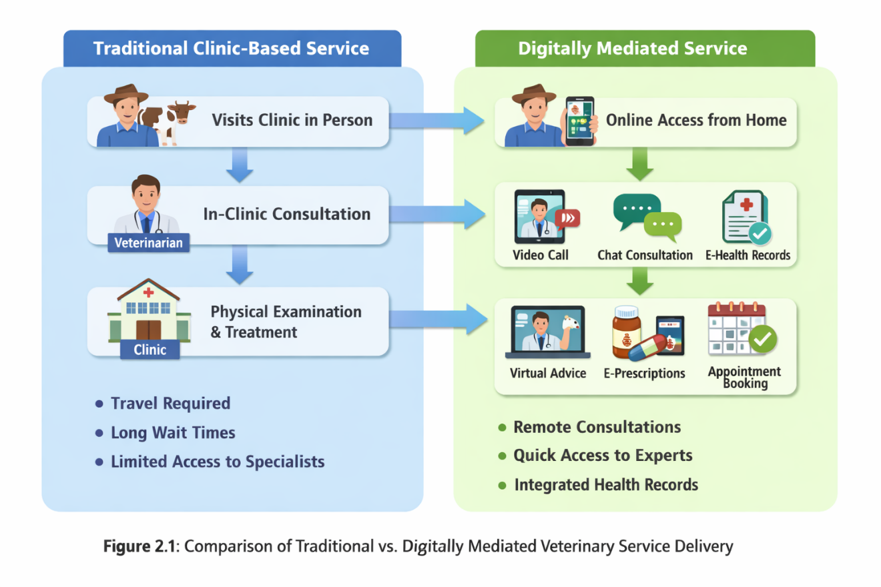

Figure 2.1 Comparison of Traditional vs. Digital Mediated Veterinary Service Delivery

### ****2.1.2 Concept of Digital Platforms in Animal Healthcare****

Digital platforms in animal healthcare are conceptualised as multi sided information systems that enable structured interaction between veterinary professionals and animal owners through shared digital infrastructure. Unlike static information websites, platform based systems support continuous service exchange, scalability, and user role differentiation (Wolfert et al., 2021). This platform logic enables veterinarians and animal owners to interact within a coordinated digital environment rather than through fragmented communication channels.

The literature identifies three core functions of digital veterinary platforms: connectivity, information management, and service coordination (Basu et al., 2023; FAO, 2022). Connectivity allows animal owners to locate and communicate with veterinarians beyond their immediate locality. Information management supports the storage, validation, and dissemination of animal health knowledge. Service coordination enables structured processes such as appointment scheduling, follow ups, and reminders that are essential for preventive care adoption.

However, empirical studies caution that platform effectiveness is highly context dependent. Systems designed without consideration for digital literacy, infrastructural constraints, and trust mechanisms often experience low adoption and limited impact (Ibrahim et al., 2023; Lwoga, 2017). In Nigeria, unreliable internet connectivity and limited exposure to digital health tools necessitate platforms that prioritise usability, low bandwidth optimisation, and professional verification (PositiveNaija, 2022).

Recent agricultural technology research emphasises that digital platforms must align with local practices and institutional realities to achieve sustained use (Wolfert et al., 2021; Okaiyeto et al., 2021). Within this conceptual framing, AgroPet VetConnect is positioned as a context sensitive platform that integrates veterinary expertise into a user centred digital environment.

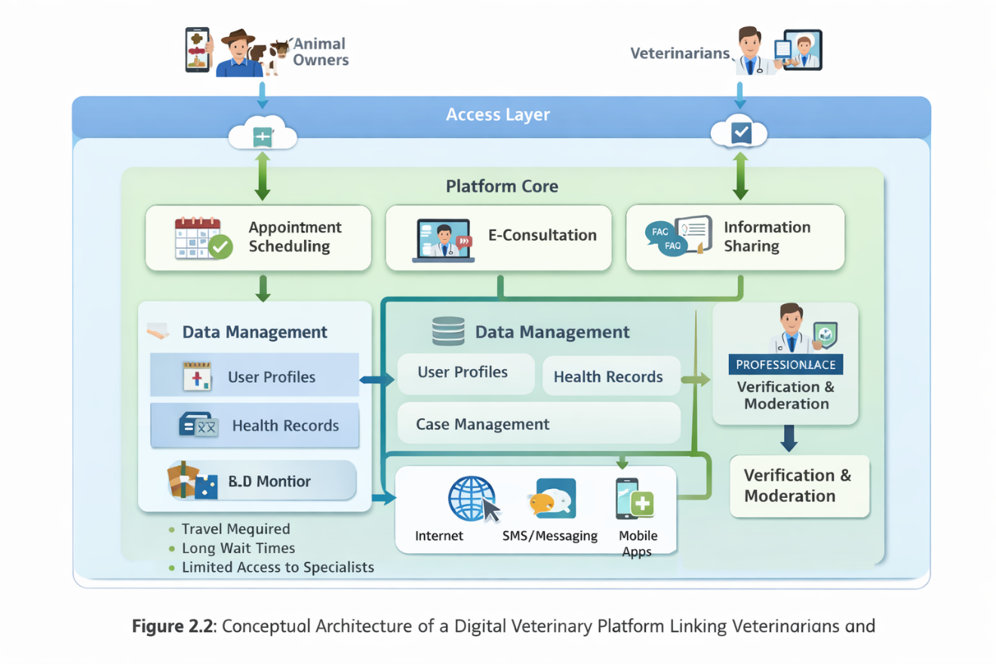

Figure 2.2 Conceptual Architecture of a Digital Veterinary Platform linking veterinarians and animal owners

### ****2.1.3 Concept of Veterinary Telemedicine****

Veterinary telemedicine refers to the use of information and communication technologies to deliver veterinary services remotely, including consultation, triage, follow up, and advisory support. Recent studies conceptualise veterinary telemedicine as a complementary extension of conventional veterinary care rather than a complete substitute for physical examination (Teller, 2020; Abu Seida et al., 2024). This distinction is critical due to ethical considerations related to diagnosis accuracy, animal welfare, and professional accountability.

Empirical evidence indicates that veterinary telemedicine is most effective for non-emergency cases, preventive guidance, and post treatment monitoring (Lundahl et al., 2022; Basu et al., 2023). In developing contexts, asynchronous communication models such as messaging and image sharing are particularly suitable due to unstable connectivity and limited access to high bandwidth devices (Ibrahim et al., 2023).

The literature also highlights regulatory and ethical challenges, particularly in jurisdictions where telemedicine guidelines are underdeveloped (OIE, 2021). Without proper verification mechanisms, telemedicine platforms risk enabling unqualified advice and misinformation. As a result, scholars increasingly advocate for telemedicine systems that integrate certified professionals within structured digital environments (Abu-Seida et al., 2024).

AgroPet VetConnect adopts this conceptualisation by focusing on communication, advisory support, and appointment coordination rather than remote diagnosis, aligning system functionality with ethical and contextual constraints.

### ****2.1.4 Concept of Centralised Veterinary Information Systems****

Centralised veterinary information systems are digital repositories that aggregate animal health data, veterinary knowledge, and service records within a unified platform. Conceptually, such systems aim to reduce information fragmentation and enhance consistency of professional advice (FAO, 2022; Lwoga, 2017). Studies show that access to reliable, centralised information improves disease awareness and adoption of preventive practices among animal owners.

However, literature identifies a persistent tension between openness and accuracy. Open platforms encourage participation but are vulnerable to misinformation, while closed systems may lack relevance and responsiveness (Chieloka et al., 2023; Wolfert et al., 2021). Contemporary research therefore advocates for hybrid models that combine expert moderation with community engagement.

In Nigeria, informal social media groups dominate veterinary information exchange but lack professional oversight (PositiveNaija, 2022). Centralised platforms with verified veterinary contributors are therefore conceptualised as mechanisms for mediating trust and improving information quality. AgroPet VetConnect aligns with this approach by embedding certified veterinarians within a moderated information environment.

### ****2.1.5 Concept of Appointment Scheduling and Preventive Animal Healthcare****

Appointment scheduling systems are digital tools that structure interactions between service providers and clients within defined timeframes. In veterinary care, such systems support preventive practices by enabling routine check-ups, vaccination schedules, and follow up consultations (Lundahl et al., 2022; FAO, 2022). Preventive animal healthcare is widely recognised as a cost-effective strategy for improving livestock productivity and animal welfare.

Studies identify poor scheduling and weak reminder mechanisms as major barriers to preventive care adoption among smallholder farmers (OIE, 2021; Okaiyeto et al., 2021). Digital scheduling systems address this gap by embedding reminders and structured timelines into healthcare workflows. This approach shifts veterinary care from crisis driven interaction to planned health management.

From a system design perspective, integrating scheduling functionality promotes continuous engagement between veterinarians and animal owners. AgroPet VetConnect adopts this conceptual logic to encourage proactive veterinary care practices.

## ****2.2 Thematic and Theoretical Review****

The thematic and theoretical review examines the major theories and analytical themes that explain the adoption, effectiveness, and sustainability of digital veterinary service platforms. This section moves beyond conceptual clarification to interrogate how technology adoption theories, information systems frameworks, and public health perspectives explain user behaviour, system performance, and service outcomes in digitally mediated veterinary care. These theories provide the intellectual foundation for system design decisions and justify the selection of platform features implemented in AgroPet VetConnect.

### ****2.2.1 Technology Acceptance Model and Digital Veterinary Platforms****

The Technology Acceptance Model posits that user adoption of information systems is primarily influenced by perceived usefulness and perceived ease of use (Davis, 1989). Within agricultural and veterinary contexts, this model has been widely applied to explain why farmers and service providers adopt or reject digital tools. Recent studies demonstrate that farmers are more likely to adopt digital platforms when they perceive clear practical benefits such as improved access to expert advice, reduced travel costs, and faster response times (Okaiyeto et al., 2021; Ibrahim et al., 2023).

Empirical evidence from developing economies suggests that perceived usefulness outweighs technological novelty in determining adoption. Platforms that fail to demonstrate immediate value to users often experience abandonment despite technical sophistication (Wolfert et al., 2021). In veterinary service delivery, usefulness is strongly linked to the credibility of information and the presence of certified professionals, as animal owners are reluctant to rely on unverified advice that may jeopardise livestock health (Abu Seida et al., 2024).

Perceived ease of use is equally critical, particularly in rural contexts characterised by limited digital literacy. Studies show that complex interfaces and high data consumption significantly reduce adoption among smallholder farmers (Ibrahim et al., 2023; FAO, 2022). This has direct implications for AgroPet VetConnect, which prioritises a simple user interface, minimal data requirements, and intuitive navigation to enhance acceptance. The Technology Acceptance Model therefore provides a strong theoretical justification for emphasising usability and functional relevance in the platform design.

### ****2.2.2 Diffusion of Innovation Theory and Adoption of Veterinary Technologies****

Diffusion of Innovation Theory explains how new technologies spread within social systems over time, highlighting the roles of relative advantage, compatibility, complexity, trialability, and observability (Rogers, 2003). In agricultural settings, adoption is rarely an individual decision but is shaped by social networks, professional authority, and peer influence. Research indicates that farmers are more likely to adopt digital tools when they observe successful use by trusted peers or receive endorsement from recognised professionals (Okaiyeto et al., 2021; Chieloka et al., 2023).

Relative advantage is particularly significant in veterinary service platforms, as farmers must perceive digital consultation as superior to existing informal practices. Studies show that when digital platforms offer faster access to veterinarians and reduce disease related losses, adoption rates increase substantially (Basu et al., 2023). Compatibility with existing farming practices also influences diffusion, as platforms that require drastic behavioural change often face resistance.

Complexity remains a major barrier in rural environments. Systems perceived as technically demanding or dependent on advanced devices diffuse slowly, particularly among older farmers (FAO, 2022). Diffusion theory therefore supports the design of AgroPet VetConnect as a low complexity, web based platform that aligns with existing communication habits such as messaging and appointment coordination. By embedding professional veterinary authority within the platform, the system also leverages social trust mechanisms that accelerate diffusion.

### ****2.2.3 Information Systems Success Model and Platform Effectiveness****

The Information Systems Success Model explains system effectiveness through six interrelated dimensions: system quality, information quality, service quality, use, user satisfaction, and net benefits (DeLone & McLean, 2003). This model has been widely applied in health and agricultural information systems research to evaluate platform performance beyond technical functionality.

System quality refers to reliability, usability, and responsiveness. Studies on digital agricultural platforms indicate that unstable systems and frequent downtime significantly undermine trust and continued use (Wolfert et al., 2021). Information quality is particularly critical in veterinary platforms, as inaccurate or outdated advice can lead to severe animal health consequences. Research shows that professionally validated content enhances user confidence and platform credibility (Lwoga, 2017; Abu Seida et al., 2024).

Service quality encompasses support, responsiveness, and professional interaction. In veterinary platforms, service quality is closely tied to the availability and engagement of certified veterinarians. Platforms that merely provide static information without interactive professional support tend to experience limited long term engagement (Basu et al., 2023). AgroPet VetConnect aligns with this model by integrating verified veterinarians, structured interaction, and appointment coordination, thereby enhancing user satisfaction and perceived net benefits.

### ****2.2.4 One Health Framework and Digital Veterinary Systems****

The One Health framework emphasises the interconnectedness of animal health, human health, and environmental sustainability. Within this framework, effective veterinary services are recognised as essential for preventing zoonotic disease transmission and safeguarding food security (FAO, 2022; OIE, 2021). Digital veterinary platforms are increasingly viewed as tools for operationalising One Health principles through improved surveillance, communication, and preventive care.

Recent studies highlight that delayed veterinary intervention contributes to zoonotic disease outbreaks, particularly in livestock dense regions (Basu et al., 2023). Digital platforms that facilitate early reporting and professional guidance can significantly reduce these risks. In Nigeria, where informal animal health practices are widespread, the lack of coordinated veterinary systems weakens One Health implementation (Chieloka et al., 2023). By enabling structured interaction between animal owners and certified veterinarians, AgroPet VetConnect supports preventive care and early disease management, aligning with One Health objectives. The platform therefore serves not only as a service delivery tool but also as a public health intervention that contributes to broader societal outcomes.

## ****2.3 Review of Related Empirical Literature****

This section critically reviews empirical studies that have examined digital veterinary services, agricultural technology platforms, veterinary telemedicine, and related health information systems. The review focuses on how these studies conceptualise system design, evaluate effectiveness, and address contextual challenges in both developed and developing economies. Rather than discussing each study in isolation, the section synthesises findings across the literature to identify dominant patterns, limitations, and unresolved issues relevant to the present study.

Several international studies have explored the effectiveness of veterinary telemedicine in extending access to professional care. Teller (2020) examined veterinary telemedicine adoption in Europe and found that remote consultation improved access to veterinary advice and client satisfaction, particularly for follow up care and preventive guidance. However, the study noted that telemedicine effectiveness declined in cases requiring physical examination, highlighting the importance of complementary rather than substitutive system design. Similarly, Lundahl et al. (2022) investigated veterinary telehealth experiences among clients and veterinary students and reported improved communication and convenience, while also identifying concerns related to diagnostic uncertainty and professional liability. These findings underscore the need for platforms that support advisory and coordination functions rather than full remote diagnosis.

Abu-Seida et al. (2024) conducted a multi country study on veterinary telemedicine and animal welfare, demonstrating that digital consultation systems improved early intervention and reduced unnecessary animal suffering when integrated into routine veterinary practice. However, the authors cautioned that the absence of professional verification mechanisms increased the risk of misinformation in open platforms. This reinforces the argument that digital veterinary systems must embed credential validation and professional oversight to ensure service quality.

Within the agricultural technology domain, Wolfert et al. (2021) analysed big data driven and platform based agricultural systems and concluded that digital platforms significantly enhance service coordination and decision making when aligned with user needs and institutional structures. Their findings highlight that technological sophistication alone does not guarantee impact, as adoption is constrained by usability, trust, and contextual relevance. Basu et al. (2023) further extended this analysis by examining digital health tools within the One Health framework, showing that integrated digital platforms improve disease surveillance and preventive care outcomes. Nevertheless, their study identified weak implementation in low-income countries due to infrastructural limitations and fragmented service delivery.

Empirical studies focusing on developing economies provide further insight into contextual constraints. Okaiyeto et al. (2021) examined the adoption of agricultural information systems among smallholder farmers and found that perceived usefulness and professional endorsement were stronger predictors of adoption than technological features. Farmers were more willing to engage with systems that provided direct access to trusted experts rather than static information repositories. Ibrahim et al. (2023) similarly reported that digital divide factors such as internet reliability, device access, and digital literacy significantly affected platform usage in rural Nigeria. These studies highlight the importance of designing low complexity, accessible systems that align with existing user capabilities.

Lwoga (2017) analysed web-based animal health information systems in Africa and found that most platforms lacked content validation mechanisms, resulting in inconsistent information quality. Although users valued accessibility, trust remained a critical barrier to sustained use. Chieloka et al. (2023) investigated the application of geographic information systems in livestock disease surveillance and emphasised that fragmented information systems undermine coordinated disease management. Their study recommended integrated platforms that connect veterinarians, farmers, and institutions within a shared digital environment.

Research by the Food and Agriculture Organization (2022) demonstrated that digital platforms supporting appointment scheduling and preventive care significantly improved vaccination compliance and disease prevention outcomes in pilot agricultural programmes. However, the report noted that most existing platforms focus on crop production, with limited emphasis on veterinary service coordination. The World Organisation for Animal Health (2021) similarly highlighted the absence of structured digital veterinary systems in many developing countries, identifying this gap as a major obstacle to effective animal health governance.

Nigerian focused studies further illustrate systemic deficiencies. Babalobi (2007) identified long standing challenges in veterinary service accessibility and coordination, many of which remain unresolved despite technological advancement. PositiveNaija (2022) reviewed Nigerian animal health applications and found that most platforms provide informational content without integrating certified veterinarians or structured service workflows. This limits their capacity to deliver reliable and actionable veterinary support.

More recent empirical work by Basu et al. (2023) and Abu Seida et al. (2024) suggests that hybrid digital platforms combining professional interaction, information management, and service coordination offer the most promise for improving veterinary care outcomes. However, these studies were largely conducted outside Nigeria and did not address local infrastructural constraints or cultural factors influencing adoption.

Collectively, the reviewed literature demonstrates that digital veterinary platforms can improve access to professional care, enhance preventive practices, and support coordinated service delivery. However, the evidence also reveals persistent limitations related to professional verification, contextual adaptation, system integration, and usability in developing economies. Most existing platforms are either information centred without interactive professional support, or telemedicine focused without structured appointment and follow up mechanisms.

## ****2.4 Identified Research and System Gap****

Despite growing empirical evidence supporting digital veterinary platforms, there is a clear gap in the literature regarding integrated, web based veterinary service systems tailored to the Nigerian context. Existing studies largely focus on telemedicine effectiveness, agricultural information dissemination, or disease surveillance in isolation. Few systems combine veterinarian verification, appointment scheduling, centralised information management, and context sensitive design within a single platform. Additionally, Nigerian specific platforms lack structured workflows that support preventive care and sustained professional engagement.

This gap underscores the need for a unified digital veterinary platform that directly connects animal owners with certified veterinarians, supports coordinated service delivery, and accommodates infrastructural and digital literacy constraints. AgroPet VetConnect is designed to address this gap by integrating professional verification, advisory support, and appointment coordination within a user centred web-based system tailored to Nigeria’s animal healthcare landscape.

## References

Abu-Seida, A. M., Abdulkarim, A., & Hassan, M. H. (2024). Veterinary telemedicine: A new era for animal welfare. Open Veterinary Journal, 14(4), 952-961. <https://doi.org/10.5455/OVJ.2024.v14.i4.2>

Babalobi, O. O. (2007). Veterinary geographic information systems applications in Nigeria: Limitations, challenges and needs. University of Ibadan Repository. <https://repository.ui.edu.ng/bitstreams/7518e15a-d9f1-462e-9c40-a6a544de4c69/download>

Basu, A., Rani, S., Okafor, C., & Bello, M. (2023). Telehealth as a component of One Health: Implications for animal and public health systems. One Health, 16, 100495. <https://doi.org/10.1016/j.onehlt.2023.100495>

Chieloka, O. S., Eze, J. I., Mohammed, A., & Lawal, I. A. (2023). Geographic information systems as a panacea to livestock disease surveillance in sub Saharan Africa. Pan African Medical Journal, 45, 118. <https://doi.org/10.11604/pamj.2023.45.118.37291>

Davis, F. D. (1989). Perceived usefulness, perceived ease of use, and user acceptance of information technology. MIS Quarterly, 13(3), 319–340. <https://doi.org/10.2307/249008>

DeLone, W. H., & McLean, E. R. (2003). The DeLone and McLean model of information systems success: A ten year update. Journal of Management Information Systems, 19(4), 9–30. <https://doi.org/10.1080/07421222.2003.11045748>

Food and Agriculture Organization of the United Nations. (2022). Digital agriculture and rural transformation. FAO. <https://www.fao.org/documents>

Ibrahim, H. Y., Suleiman, A. M., & Yusuf, M. S. (2023). Digital divide and adoption of online service platforms in rural Nigeria. Journal of African Information Systems, 15(2), 34–49.

Lundahl, L., Lindberg, J., Svensson, C., & Emanuelson, U. (2022). Experiences of veterinary telehealth clients and students: A pilot study. Frontiers in Veterinary Science, 9, 871928. <https://doi.org/10.3389/fvets.2022.871928>

Lwoga, E. T. (2017). Web based agricultural knowledge systems and the dissemination of animal health information in Africa. Information Development, 33(4), 366–378. <https://doi.org/10.1177/0266666916677794>

Okaiyeto, S. A., Oguntade, A. E., & Afolayan, O. T. (2021). Adoption of agricultural information systems among smallholder farmers in developing economies. Information Technology for Development, 27(4), 735–752. <https://doi.org/10.1080/02681102.2021.1887094>

PositiveNaija. (2022, August 27). Nigerian apps for animal health, nutrition and business. <https://www.positivenaija.com/nigerian-apps-for-animal-health-nutrition-and-business/>

Rogers, E. M. (2003). Diffusion of innovations (5th ed.). Free Press.

Teller, L. M. (2020). Veterinary telemedicine: A literature review. Veterinary Evidence, 5(4), 1–15.

Teller, L. M. (2020). Veterinary telemedicine: A systematic literature review. Veterinary Evidence, 5(4), 1–15. <https://doi.org/10.18849/VE.V5I4.317>

Wolfert, S., Ge, L., Verdouw, C., & Bogaardt, M. J. (2021). Big data in smart farming: A review. Agricultural Systems, 153, 69–80. <https://doi.org/10.1016/j.agsy.2017.01.023>

World Organisation for Animal Health. (2021). Digital technologies and animal health systems. OIE. <https://www.woah.org>